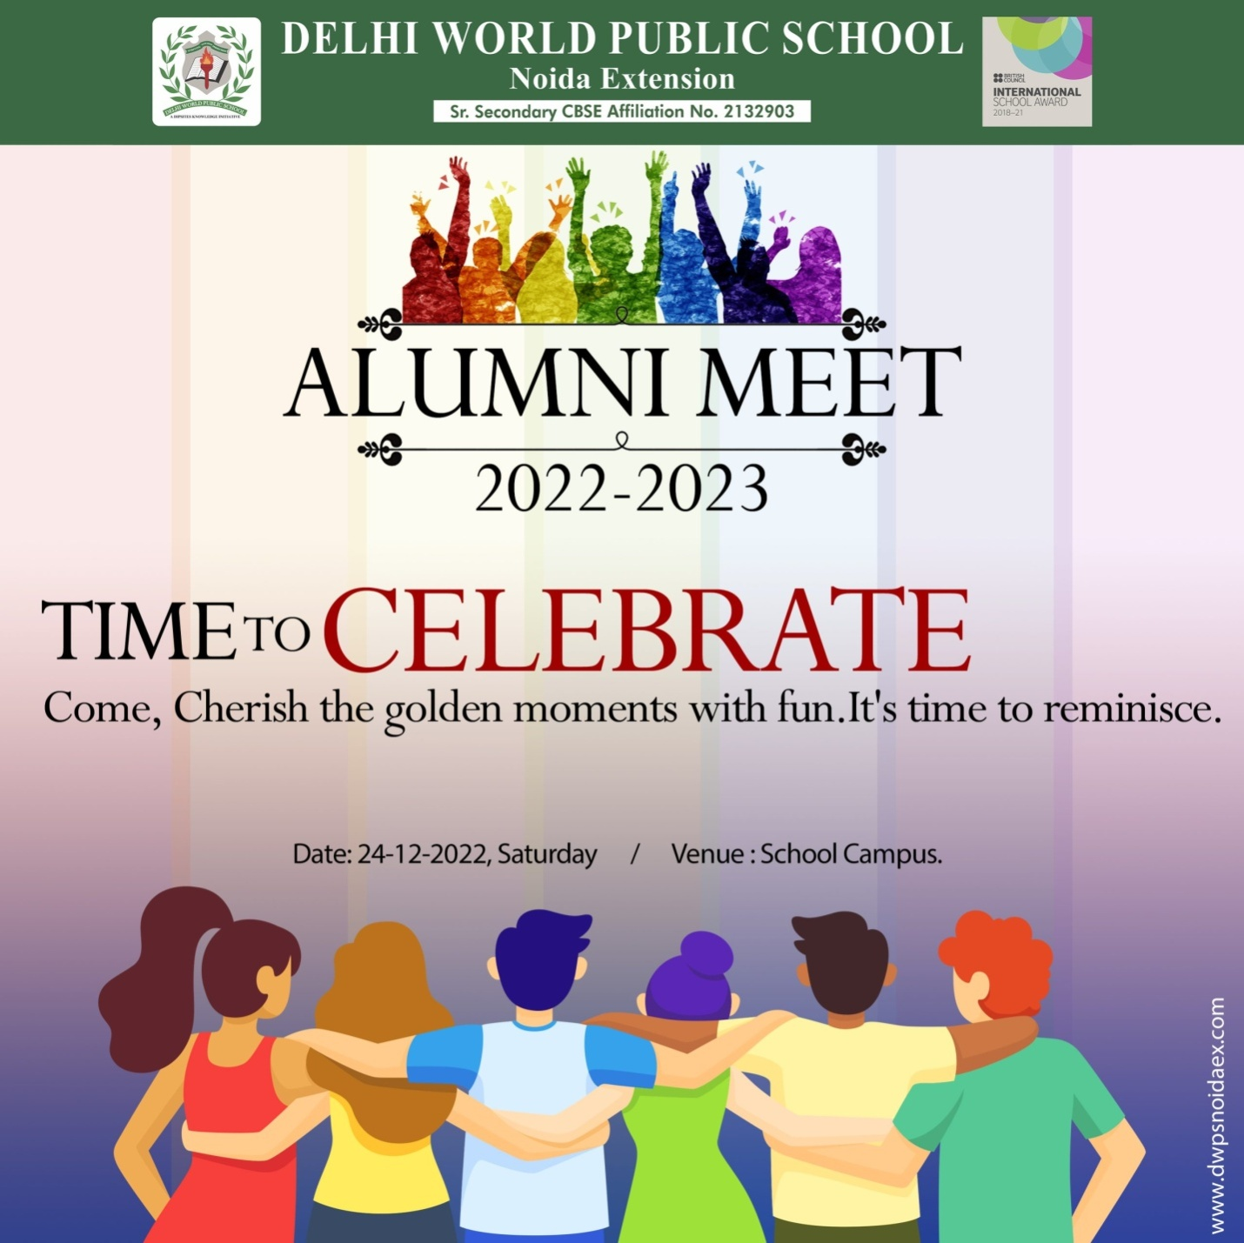

**Dear Alumni**

**We are pleased to cordially invite you to your Alma Mater to remember all the joyful moments spent together and to cherish the memorable experiences.**

**Kindly click on the link to register and confirm your esteemed presence.**

<https://forms.gle/SMFjvtB22tAZWqq68>

**Date: 12th April 2025, Saturday**

**Time: 6:00 p.m.**

**Venue: St. George’s School, Alaknanda**